**CSCI 6010 Programming Assignment #5**

**Student: Shifeng Yuan GWid: G32115270**

* I have defined the two polynomial as

* P1(x) = 3x^2+5x+5x^3

* P2(x) = 4x^2+5x+3x^5+5x^4

* The result of P1(x)+P2(x) is supposed to be

* 5x^4 + 3x^5 + 9x^3 + 10x^1 + 3x^2

* The result of P1(x)*P2(x) is supposed to be

* 15x^8 + 25x^2 + 45x^4 + 50x^6 + 34x^7 + 15x^3 + 37x^5

* The result of P1(x)-P2(x) is supposed to be

* -3.0x^5 -5.0x^4 + 3.0x^2 + 1.0x^3

* The result of P1(x)/P2(x) is supposed to be

* 1.0x^2 + 1.67x^-4 + 2.25x^0 + 3.52x^-2 + 2.00x^-3 + 0.60x^1 + 1.75x^-1

The results of the program:

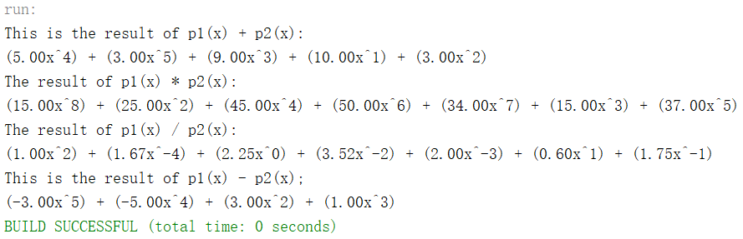

Thank you for reviewing my homework!